Management Information Systems Managing the digital firm, 12th
Chapter 1
  - Transaction Cost Theory & Agency Cost Theory:
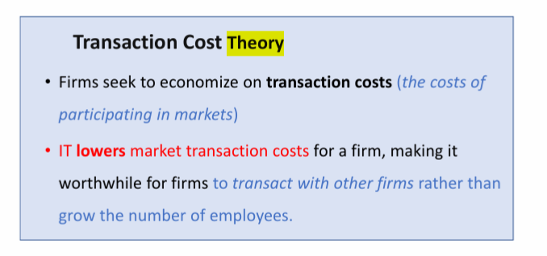
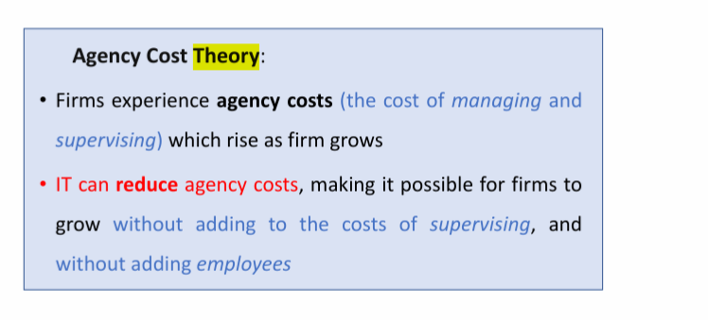
  - Business value chain model ( Primary activities & Support Activities )
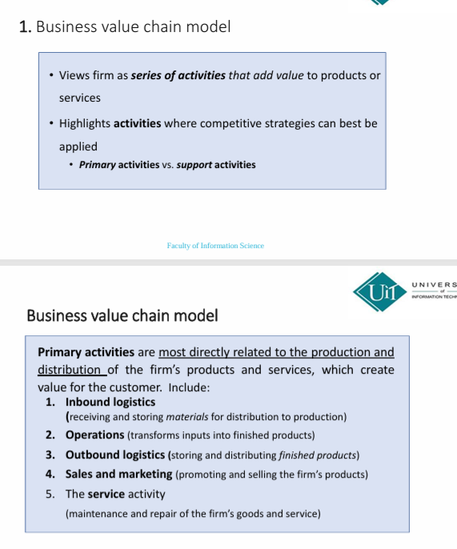
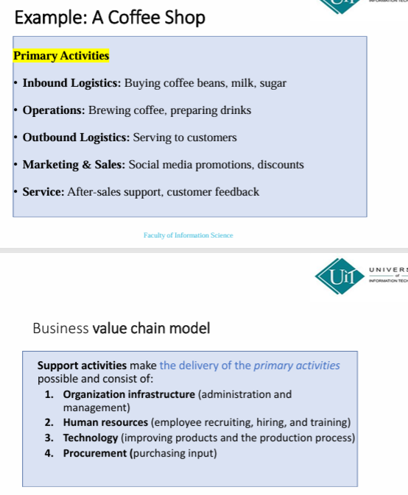
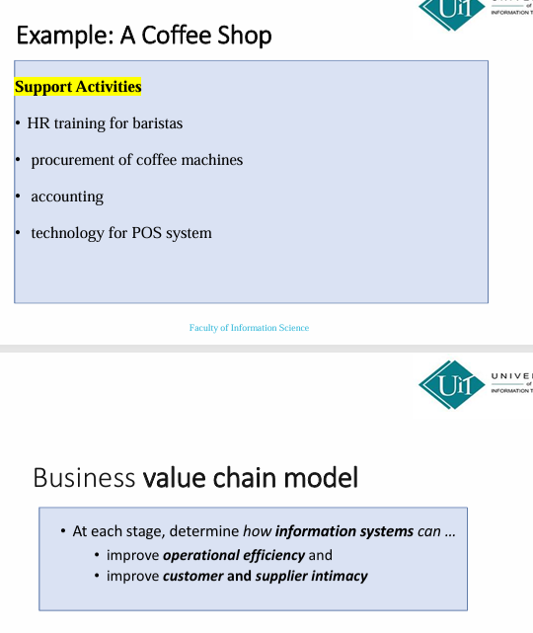
Chapter 6
  - Data warehouse & Data Mart
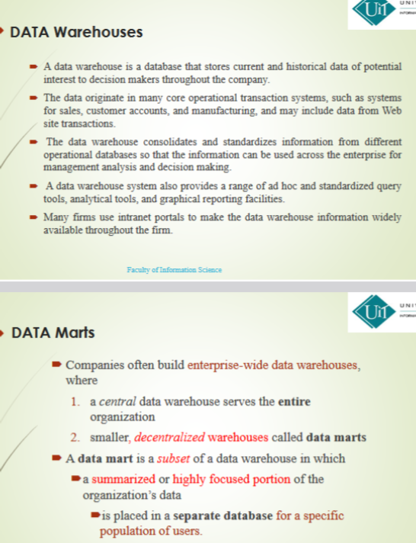
  - OLAP and Data Mining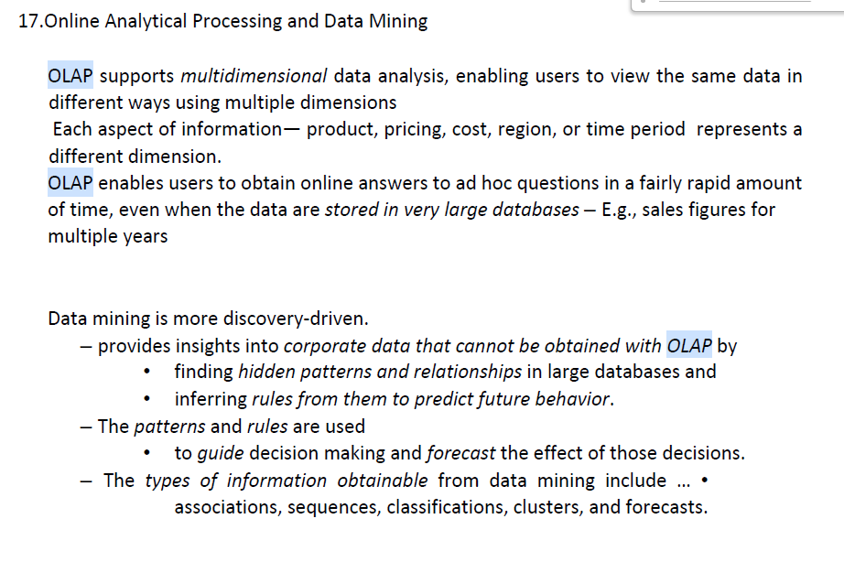
Chapter 11
  - Tacit knowledge. & Explicit knowledge.
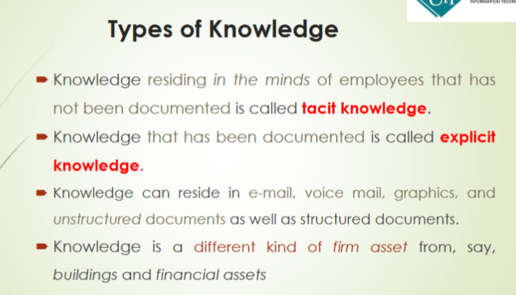
Chapter 13
- Structural organizational changes enabled by IT
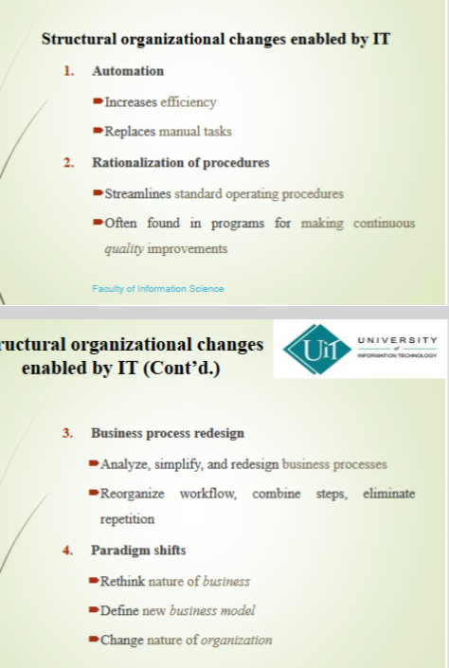
- Four main strategies of Conversion ( Paralledi, Doirect Cutover , Pilot , and Phased approach )
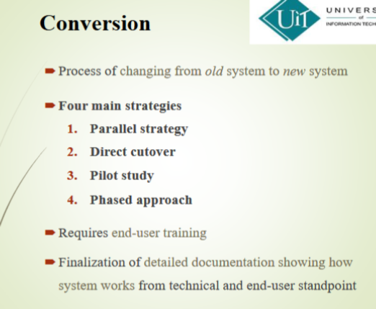

1. Parallel Strategy
- The old system and the new system run at the same time for a period.
- This is the safest method because the old system
- can be used if the new one fails.
- However, it is expensive and may need extra staff and resources.
2. Direct Cutover Strategy
- The old system is completely replaced by the new system on a specific day.
- This method is very risky because there is no backup system.
- If problems occur, disruptions and costs can be very high.
3. Pilot Study
- The new system is first introduced in one small area, such as one department.
- If it works well, it is then implemented in the rest of the organization, either all at once or step by step.
4. Phased Approach

- The phased approach strategy introduces the new system in stages, either by
functions or by organizational units.

Short Notes & Multiple Choice
1. Introduction to digital business and e-commerce
- E-Commerce & E-Business
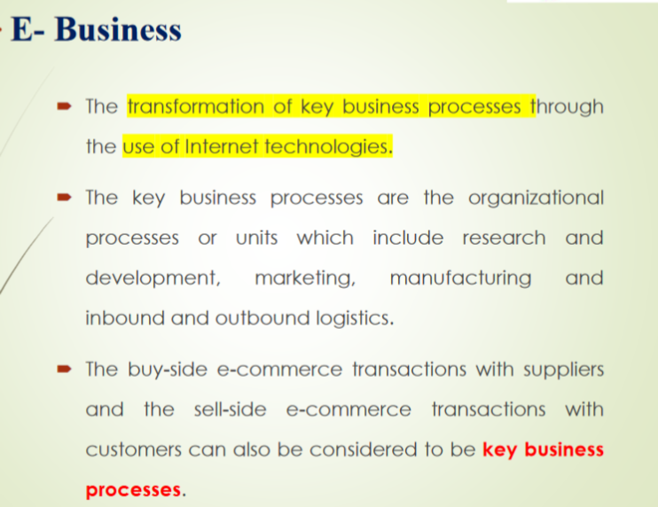
- Relationship between e-business and e-commerce
- Drivers of business Internet adoption
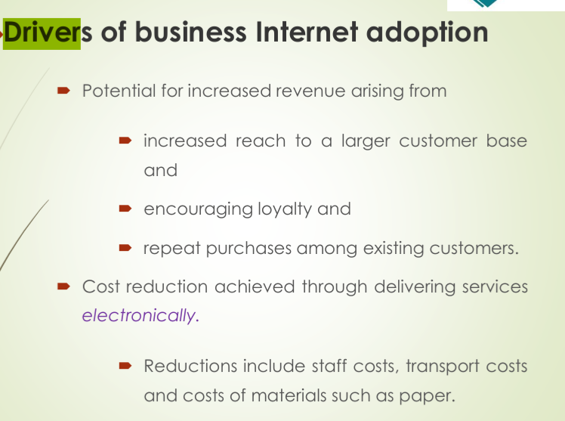
- Drivers of consumer Internet adoption( Six Cs)
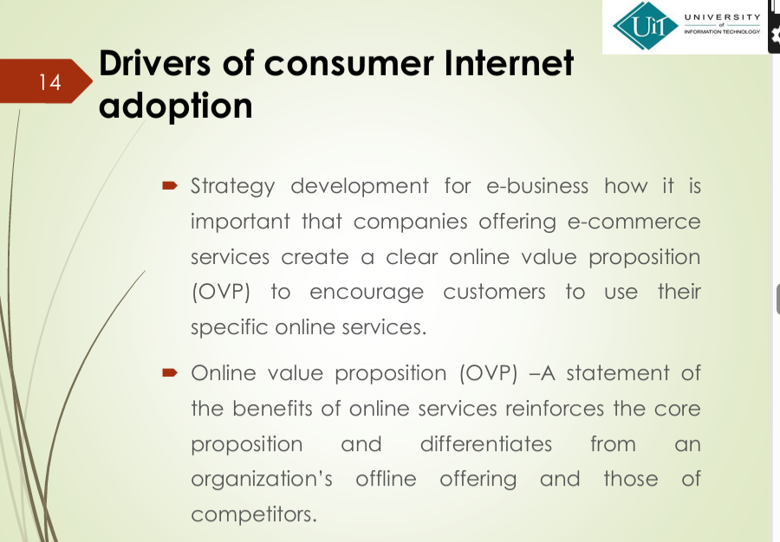
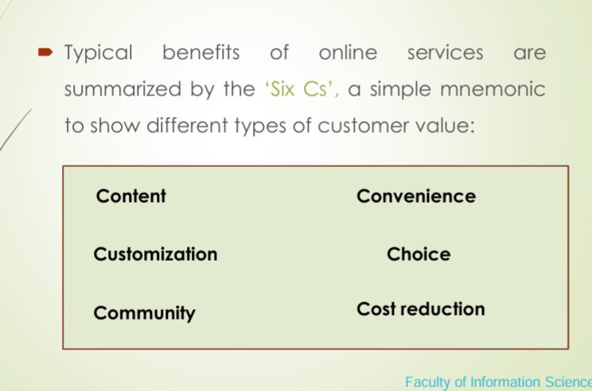

2. Marketplace analysis for e-commerce
- Marketplace channel structures
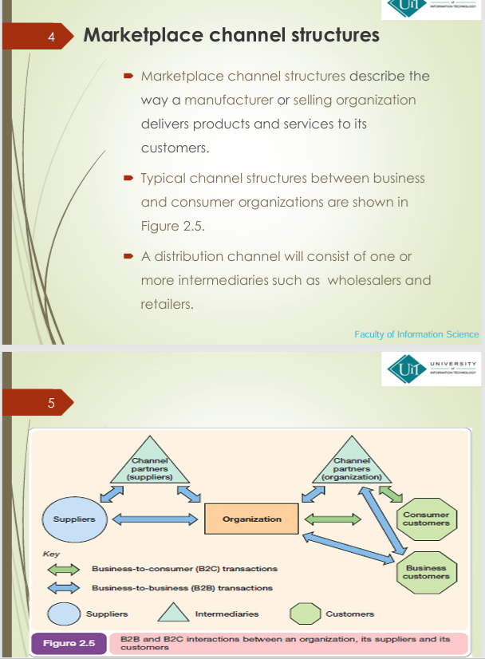
- Burn Rate & Churn Rate
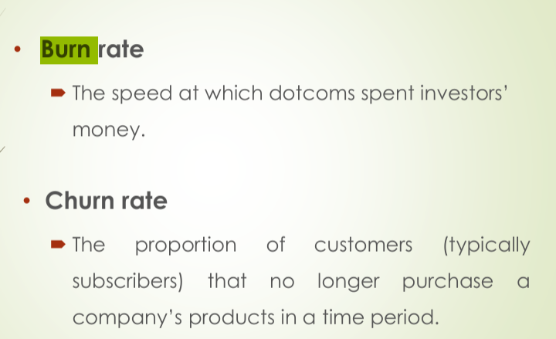
3. Managing digital business infrastructure
- Different types of convergence
+ 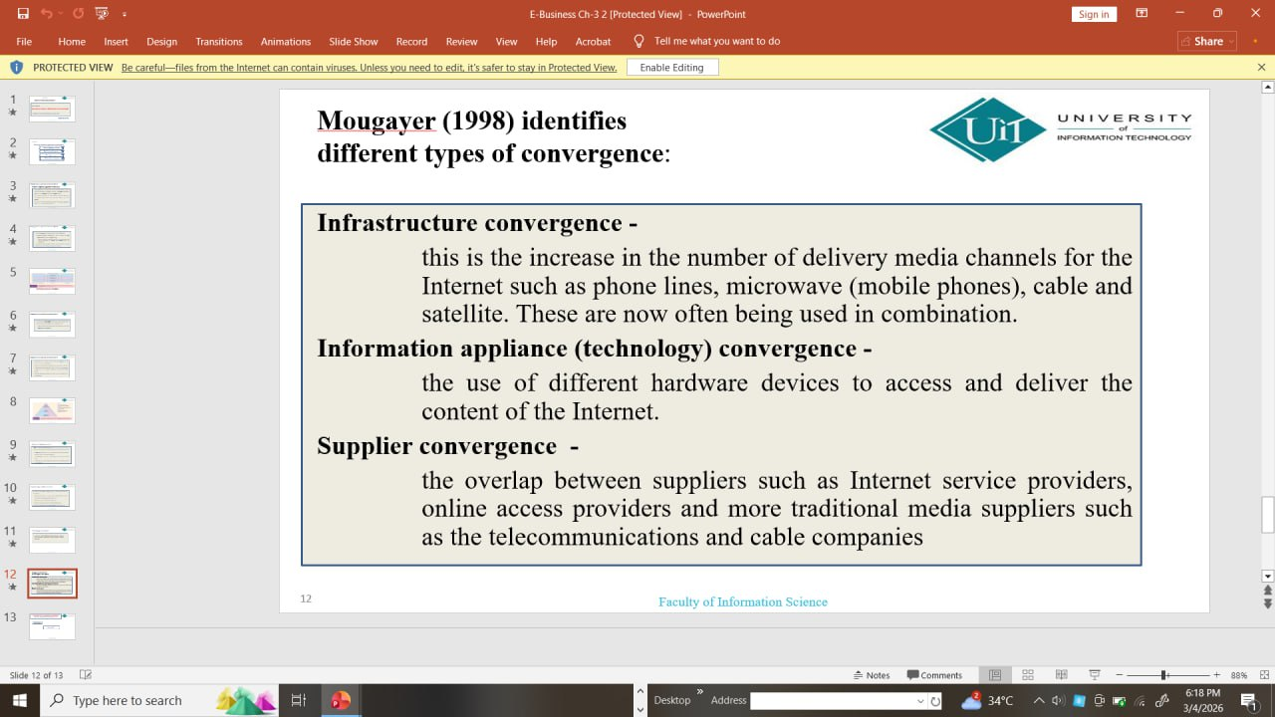
5. E-Business Strategy
- Prescriptive strategy & Emergent strategy
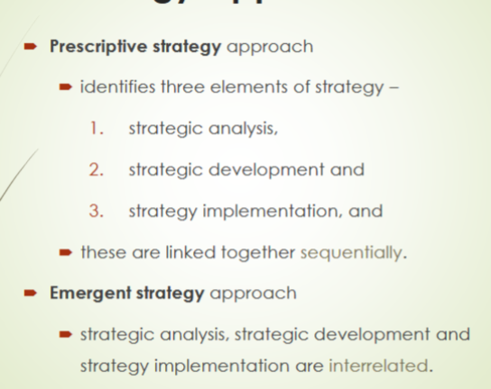
6. Supply chain management
- Push and pull supply chain
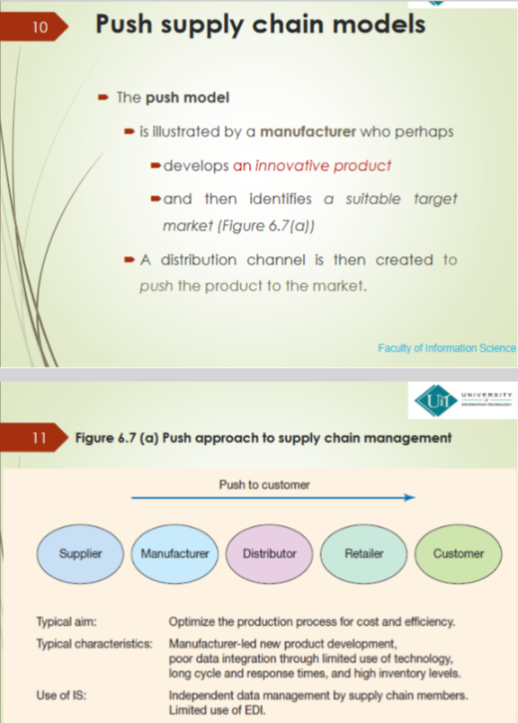
xx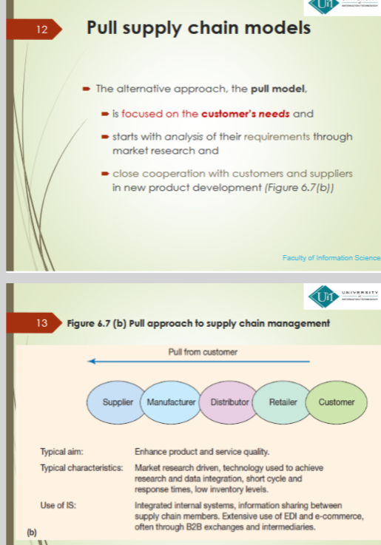
7. e-procurement
- Procurement
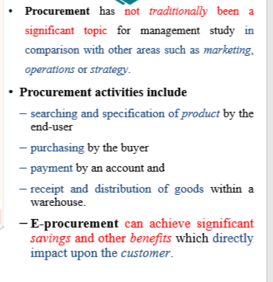
Types of Procurement
• There are two broad categories of procurement:
1. production-related procurement those that relate to manufacturing of products
2. operating or nonproduction-related procurement that supports the operations of the whole business and includes
- office supplies, furniture, information systems, MRO goods and professional services such as consulting and training.
- Raw materials for the production of goods and MRO (Maintenance, repairs and operations of manufacturing facilities) goods are particularly important since they are critical to the operation of a business.
- Procurement also includes the transport, storage and distribution of goods received within the business – this is referred to as ‘inbound logistics’.
Benefits of e-procurement
- Reduced purchasing cycle time and cost
- Enhanced budgetary control
- Elimination of administrative errors
- Increasing buyers’ productivity
- Lowering prices through product standardization and consolidation of buys
- Improving information management (better access to prices from alternative suppliers and summaries of spending)
- Improving the payment process (this does not often occur currently since payment is not always integrated into e-procurement systems).

Risks and impacts of e-procurement
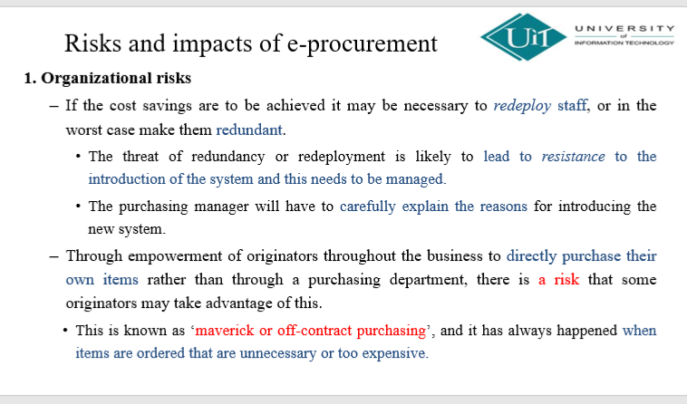
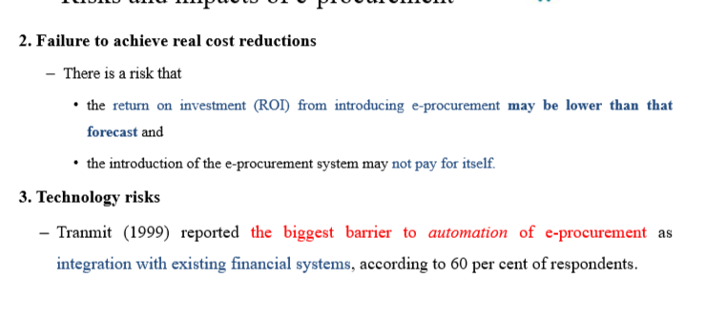

Long Question
- Introduction to digital business and e-commerce
- Different types of sell-side e-commerce
1. Transactional e-commerce site.
2. Services-oriented relationship-building web site.
3. Brand-building site.
4. Portal or media site
- Transactional e-commerce site
- These enable purchase of products online.
- The main business contribution of the site is through sale of these products.
- The sites also support the business by providing information for consumers that prefer to purchase products offline.
- These include retail sites, travel sites and online banking services.
- Services-oriented relationship-building web site
- Provide information to stimulate purchase and build relationships.
- Products are not typically available for purchase online.
- Information is provided through the web site and e-newsletters to inform purchase decisions.
- The main business contribution is through encouraging offline sales and generating enquiries or leads from potential customers.
- Such sites also add value to existing customers by providing them with detailed information to help support them in their lives at work or at home.
- Brand-building site
- Provide an experience to support the brand.
- Products are not typically available for online purchase.
- Their main focus is to support the brand by developing an online experience of the brand.
- They are typical for low-value, high-volume fast moving consumer goods (FMCG brands) for consumers.
- Portal or media site
- Provide information, news or entertainment about a range of topics. ‘Portal’ refers to a gateway of information.
- This is information both on the site and through links to other sites.
- Portals have a diversity of options for generating revenue, including advertising, commission-based sales, sale of customer data (lists).
- Social networks can also be considered to be in this category since they are often advertising-supported.

2. Marketplace analysis for e-commerce
- Eight key elements of the business model
Key elements of the business model
Investors will require eight key elements of the business model to be defined which will summarize the organization’s e-business strategy:
- Value proposition
- Which products and/or services will the company offer?
- Market or audience
- Which audience will the company serve and target with its communications?
- For example, business-to-business, business-to-consumer or not-for-profit?
- Revenue models and cost base
- What are the specific revenue models that will generate different income streams?
- What are the main costs of the business forming its budget?
- How are these forecast to change through time?
- Competitive environment
- Who are the direct and indirect competitors for the service and which range of business models do they possess?
- Value chain and marketplace positioning
- How is the company and its services positioned in the value chain between customers and suppliers and in comparison with direct and indirect competitors?
- Representation in the physical and virtual world
- What is its relative representation in the physical and virtual world, e.g. high-street presence, online only, intermediary, mixture?
- How will the company influence its audience through the buying process through multichannel marketing?
- Organizational structure
- How will the organization be internally structured to create, deliver and promote its service?
- How will it partner with other companies to provide services, for example through outsourcing?
- Management
- What experience in similar markets and companies do the managers have?
- What is their profile which can be helpful to attract publicity?
- Online marketplace analysis
Analysis of the online marketplace or ‘marketspace’
is a key part of
❖ developing a long-term e-business plan or
❖ creating a shorter-term digital marketing campaign.
❖ the relative importance of different online intermediaries in the marketplace and
❖ the flow of clicks between your different customer segments, your company site(s) and
different competitors via the intermediaries.
- Customer segments
Marketplace analysis identifies different customer groups for an online business. It helps understand what media they use, how they buy products, and what type of content and website experience they expect.
- Search intermediaries
These are the main search engines in each country. Typically they are Google, Yahoo!,
- Intermediaries and media sites
Media sites and other intermediaries are often successful in attracting visitors via search or direct since they are mainstream brands.
Companies need to assess potential online media and distribution partners
- Destination sites
These are the sites that the marketer is trying to generate visitors to, whether these are transactional sites, like retailers, financial services or travel companies or manufacturers or brands.

. 4. e-environment
SLEPT framework
SLEPT stands for Social, Legal, Economic, Political and Technological factors.
- Social factors – these include the influence of consumer perceptions in determining usage of the Internet for different activities.
- Legal and ethical factors – determine the method by which products can be promoted and sold online. Governments, on behalf of society, seek to safeguard individuals’ rights to privacy.
- Economic factors – variations in the economic performance in different countries and regions affect spending patterns and international trade.
- Political factors – national governments and transnational organizations have an important role in determining the future adoption and control of the Internet and the rules by which it is governed.
- Technological factors – changes in technology offer new opportunities to the way products can be marketed.
Six reasons why it believes e-commerce is green
E-commerce is green
Identified six reasons why it believes e-commerce is green. They are:
- Less vehicle-miles
- Lower inventory requirements
- Fewer printed materials
- Less packaging
- Less waste
- Dematerialization
Less vehicle-miles
Shopping is the most frequent reason for car travel in the UK, accounting for 20% of all trips, and for 12% of mileage.
A study by the Swiss online grocer LeShop.ch calculated that each time a customer decides to buy online rather than go shopping by car, 3.5 kg of CO2 emissions are saved.
Lower inventory requirements
The trend towards pre-selling online– i.e. taking orders for products before they are built, as implemented by Dell avoids the production of obsolete goods that have to be disposed of if they don’t sell, with associated wastage in energy and natural resources.
Fewer printed materials
Online e-newsletters and brochures replace their physical equivalent so saving paper and distribution costs.
Less packaging
Although theoretically there is less need for fancy packaging if an item is sold online this argument is less convincing, since most items like software or electronic items still come in packaging.
At least those billions of music tracks downloaded from iTunes and Napster don’t require any packaging or plastic.
Less waste
Across the whole supply chain of procurement, manufacturing and distribution,
the Internet can help reduce product and distribution cycles.
Some even claim that auction services like eBay and Amazon Marketplace which enable redistribution of second-hand items can promote recycling.
Dematerialization
Better known as ‘digitization’, this is the availability of products like software, music and video in digital form.
Chapter 3
Michael Porter’s competitive forces model
Provides general view of firm, its competitors, and environment
Five competitive forces shape fate of firm
- Traditional competitors
- New market entrants
- Substitute products and services
- Customers
- Suppliers
- Traditional competitors
All firms share market space with competitors who are continuously devising new products, services, efficiencies, switching costs.
- New market entrants
Some industries have high barriers to entry, e.g. computer chip business
New companies have new equipment, younger workers, but little brand recognition
- Substitute products and services
§ Substitutes customers might use if your prices become too high, e.g. iTunes substitutes for CDs
- Customers
Can customers easily switch to competitor’s products?
Can they force businesses to compete on price alone in transparent marketplace?
- Suppliers
Market power of suppliers can have a significant impact on firm profits, especially when firm cannot raise prices as fast as suppliers.
In Porter’s competitive forces model, the strategic position of the firm and its strategies are determined
- not only by competition with its traditional direct competitors
- but also, by four other forces in the industry’s environment: new market entrants, substitute products, customers, and suppliers.
5. E-Business Strategy
- Four-stage strategy process model
Four main strategies
- Parallel strategy
- Direct cutover
- Pilot study
- Phased approach
- Requires end-user training
- Finalization of detailed documentation showing how system works from technical and end-user standpoint
Parallel strategy
- In a parallel strategy, both the old system and its potential replacement are run together for a time until everyone is assured that the new one functions correctly.
- This is the safest conversion approach because, in the event of errors or processing disruptions, the old system can still be used as a backup.
- However, this approach is very expensive, and additional staff or resources may be required to run the extra system.
Direct cutover strategy
- The direct cutover strategy replaces the old system entirely with the new system on an appointed day.
- It is a very risky approach that can potentially be more costly than running two systems in parallel if serious problems with the new system are found.
- There is no other system to fall back on.
- Dislocations, disruptions, and the cost of corrections may be enormous.
Pilot study
- The pilot study strategy introduces the new system to only a limited area of the organization, such as a single department or operating unit.
- When this pilot version is complete and working smoothly, it is installed throughout the rest of the organization, either simultaneously or in stages.
Phased approach
- The phased approach strategy introduces the new system in stages, either by functions or by organizational units.
7. e-procurement
- Different types of information system cover different parts of the procurement cycle
- Different types of information system cover different parts of the procurement cycle.
- The different type of systems are as follows.
  - Stock control system– It is mainly used for production purchasing. The system gives an alert to reorder when stock levels fall below the set minimum level.
  - CD or web-based catalogue – paper catalogues have been replaced by electronic forms that make it quicker to find suppliers.
  - E-mail- or database-based workflow systems :The system connects order entry, manager approval, and buyer placement in one process. The order moves from one person to another and waits in their inbox for action. It can also be linked to the accounting system.
  - Order-entry on web site – the buyer often has the opportunity to order directly on the supplier’s web site, but this will involve rekeying and there is no integration with systems for requisitioning or accounting.
  - Accounting systems – Networked accounting systems allow buying staff to enter orders, which accounting staff can then use to make payments when invoices arrive.
  - Integrated e-procurement or ERP systems – these aim to integrate all the facilities above and will also include integration with suppliers’ systems.

- Digital marketing
- Separate e-marketing plan is valuable in many small and medium organizations
- A separate e-marketing plan is valuable in many small and medium organizations, there is likely to be no e-marketing plan.
- These problems are typical and commonplace when there is no clear planning or control for e-marketing.
1.Customer demand for online services will be underestimated if it hasn’t been researched, lacks sufficient resources, or has no clear or realistic objectives.
2.Competitors, both existing and new, will gain market share if e-marketing resources are insufficient and strategies are unclear.
3.Resources may be duplicated, for example, different teams buying the same tools or hiring separate agencies for similar online marketing tasks.
4. There may not be enough resources or specialist skills for e-marketing, making it difficult to compete effectively.
5.Insufficient customer data are collected online as part of relationship building and these data are not integrated well with existing systems.
6. Opportunities to improve efficiency through online marketing, such as lower communication costs and higher customer conversion and retention, may be missed.
7. Opportunities to use online marketing tools like search or email marketing may be missed, or done inefficiently if the wrong resources or tools are used.
8. Changes to internal IT systems by different teams may not be prioritized properly.
9.Online marketing results are not tracked thoroughly, either in detail or overall.
10.Senior management does not provide enough support for e-marketing, which is often a key strategic initiative.

Chapter 11
Knowledge Management Value Chain
- The Knowledge Management Value Chain is a framework that shows how knowledge is created, captured, stored, shared, and applied in an organization to generate business value and competitive advantage.
Main Stages of Knowledge Management Value Chain
- Knowledge Acquisition (Creation / Capture)
- Knowledge Storage
- Knowledge Dissemination (Sharing)
- Knowledge Application
Knowledge Acquisition (Creation / Capture)
- Documenting tacit and explicit knowledge
- Storing documents, reports, presentations, best practices
- Unstructured documents (e.g., e-mails)
- Developing online expert networks
- Creating new knowledge by discovering patterns in corporate data
- Tracking data from TPS and external sources
Knowledge Storage
- Databases
- Document management systems that digitize, index, and tag documents according to a coherent framework
Role of management:
- Support development of planned knowledge storage systems
- Encourage development of corporate-wide schemas for indexing documents
- Reward employees for taking time to update and store documents properly
Knowledge Dissemination (Sharing)
- Portals
- Push e-mail reports
- Search engines
- Collaboration tools
- Training programs, informal networks, and shared management experience help managers focus attention on important information
Knowledge Application
- To provide return on investment, organizational knowledge must become systematic part of management decision making and become situated in decision support systems
- Ultimately, new knowledge must be built into a firm’s business processes and key application systems, including enterprise applications for managing key internal business processes and relationships with customers
- New business practices
- New products and services
- New markets

